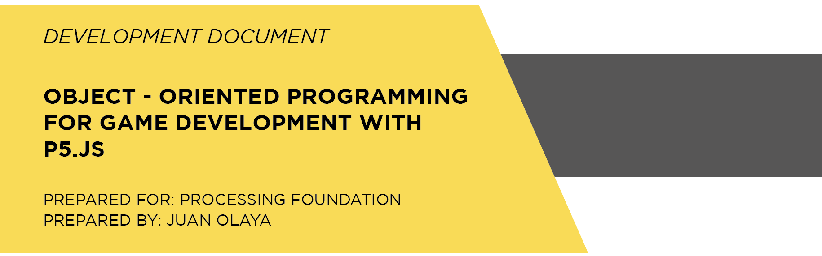

**PROJECT DEVELOPMENT**

This project called **Object-Oriented Programming for Game Development with p5.js** is an online book that explains how to develop 2D video games using p5.js through of 20 lessons.

This project is going to be developed under the Scrum methodology for project developments. Scrum allows have a functional product at the end of each spring, permanent communication between the stakeholders and adjust requirements during the development of the project. Thus, the development of this project has 3 main stages:

1. **Project definition:** Agree with the mentor on the scope of the project and the activities to be carried out. Moreover, define with the mentor the tool to develop the online book. However, I propose to develop the book online using html and JavaScript.
2. **Project development:** The stage of the development of the project is divided into 4 springs. In each spring takes 2 weeks and develops a set of 5 lessons which have the following activities:

* Write the description text of the lesson
* Implement the code or translate it into p5.js in case it is written in Processing
* Elaborate the code documentation
* Elaborate the Class diagram in case it is not done
* Upload the code to OpenProcessing and embed the sketch in the online book website
* Perform unit and integration tests

1. **Release of the project:** The last stageis preparation for the release. For this project is planned to conduct integration testing and write a report on the outcome of the project.

**TIMELINE**

Below is the Gantt chart with the dates of execution of each activity. According with this Gantt chart the project will be operative on May 20, 2019. Due to the fact that Scrum is an agile methodology for software project development the schedule is able to adapt to adjustments and requirement changes.

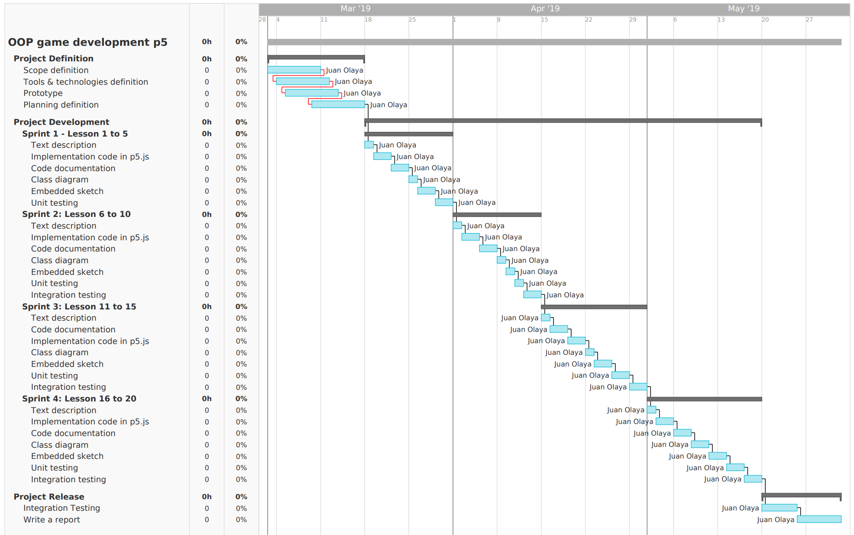

**MENTOR**

I am looking forward to obtain a constant feedback from the mentor in each stage of the development of the project. I would prefer to have a mentor that know the object-oriented programming paradigm in order to discuss the best method develop and explain object-oriented concepts.